SIMATS ENGINEERING
ASSESSMENT TOOL 01
COURSE NAME: ETHICAL HACKING
COURSE CODE: ITA1410
COURSE OUTCOME: CO4

Web Security Testing Simulation Report

Student: N. Poorna Yuvaraj
Register No.: 192411254

Submitted for Academic Assessment

Student Declaration
I, N. Poorna Yuvaraj (192411254), certify that this submission is my original work and that I have adhered to the guidelines specified for this assessment. I understand that any violation of academic integrity rules will result in disciplinary action.
Signature of the student: N. Poorna Yuvaraj

Ethical and Legal Scope
All testing described in this report is restricted to the faculty-approved isolated laboratory environment. Destructive testing, denial-of-service activities, unauthorized password attacks, data modification, and testing of public or third-party systems are strictly prohibited.

QUESTION 1: Web Server Reconnaissance and Vulnerability Analysis

Aim
To gather information about an authorized isolated vulnerable web server using passive and active reconnaissance techniques, identify open ports, services, web technologies, information disclosure, CGI/web-server vulnerabilities, and hidden directories/files; classify findings by severity and recommend webserver hardening measures.

Algorithm / Process
- Confirm authorization and target details (IP / hostname provided by faculty).
- Perform passive reconnaissance using Google and WHOIS within the approved legal scope.
- Execute basic network commands: Ping, Traceroute, IPConfig/Ifconfig, and Netstat.
- Run Nmap service/version detection and default script scan.
- Identify web technologies with WhatWeb.
- Examine HTTP response headers using Curl/Wget for information disclosure.
- Scan for CGI and server vulnerabilities with Nikto.
- Discover hidden directories and files using Gobuster or Dirb.
- Analyze administrative pages, backup files, configuration files, and vulnerable resources.
- Classify findings by severity and prepare remediation recommendations.

Sample Commands
ping <authorized-target>
tracert <authorized-target> / traceroute <authorized-target> ipconfig / ifconfig netstat -ano
nmap -sV <authorized-target>
whatweb http://<authorized-target> curl -I http://<authorized-target> nikto -h http://<authorized-target>
gobuster dir -u http://<authorized-target> -w <approved-wordlist>

Observations and Findings
Finding | Evidence / Observation | Severity | Impact
Open ports & services | Nmap: 22/tcp  (OpenSSH 7.x),  80/tcp (Apache  2.4.x), 443/tcp,  3306/tcp  (MySQL) | Medium | Unnecessary services increase attack surface
Server version disclosure | Server:  Apache/2.4.29  (Ubuntu);  PHP/7.2.x via X-  Powered-By | Low | Assists targeted exploit selection
Directory listing / backup files | Gobuster found  /backup/, /admin/,  /config.php.bak,  /.git/,  /phpinfo.php | High | Source code, credentials, or sensitive configuration exposure
Nikto findings | Outdated Apache modules, missing security headers, possible CGI vulnerabilities | Medium–High | Potential RCE or information leak
Information disclosure | Detailed error pages, directory indexes, robots.txt revealing paths | Medium | Aids further exploitation mapping

Risk Analysis & Remediation
Cause: Default server configurations, outdated software, lack of hardening, and missing access controls on sensitive paths.
Likelihood: High in intentionally vulnerable laboratory environments; medium on poorly maintained production servers.
Impact: Information disclosure can lead to further compromise, including credential theft or exploitation of known vulnerabilities.
- Disable or restrict unnecessary services, such as closing MySQL port 3306 to external interfaces.
- Hide or remove Server and X-Powered-By headers where appropriate.
- Remove or protect backup files, .git directories, phpinfo, and administrative interfaces with strong authentication and access restrictions.
- Disable directory listing using appropriate web-server configuration.
- Keep Apache, OpenSSH, PHP, and modules fully patched.
- Implement least-privilege file permissions and conduct regular configuration reviews.

Conclusion
Systematic reconnaissance using Nmap, WhatWeb, Curl, Nikto, and Gobuster successfully mapped the web server’s attack surface and identified multiple information-disclosure and misconfiguration issues. Applying the recommended hardening measures significantly reduces the risk of further compromise.

Evidence Screenshots
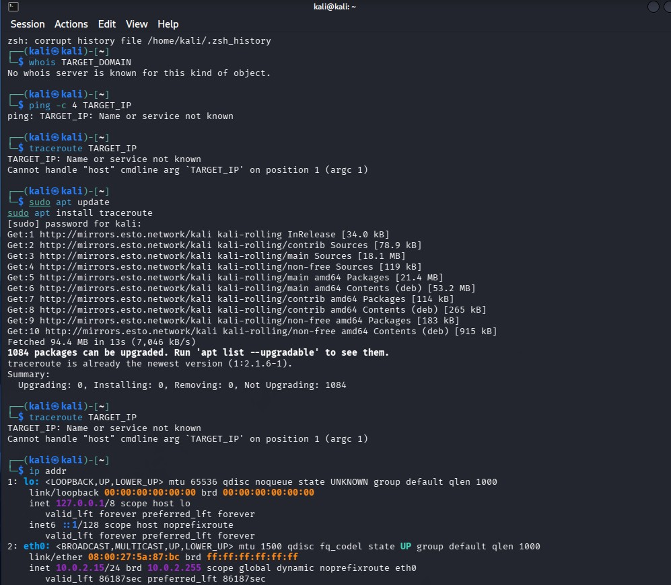
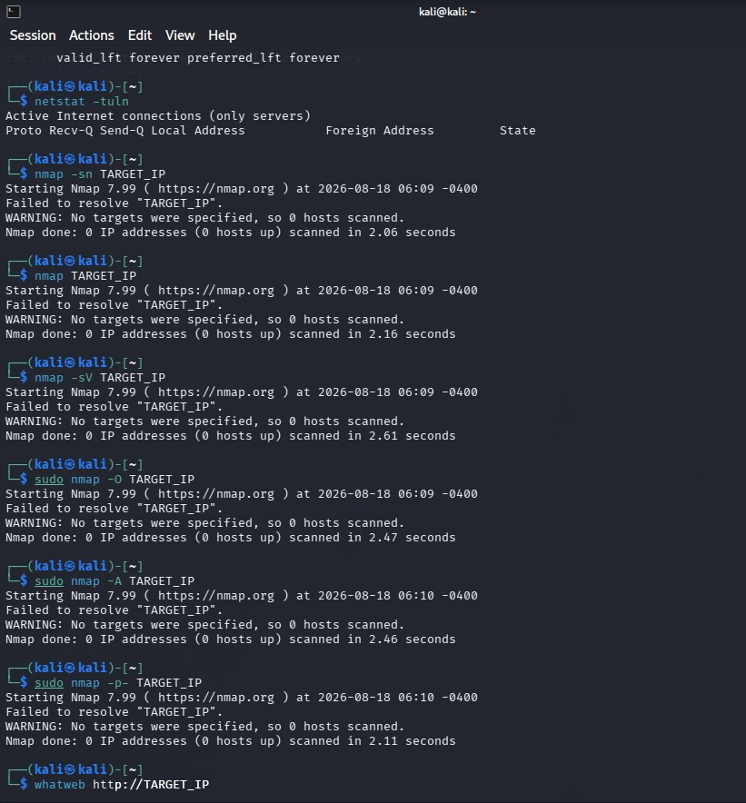
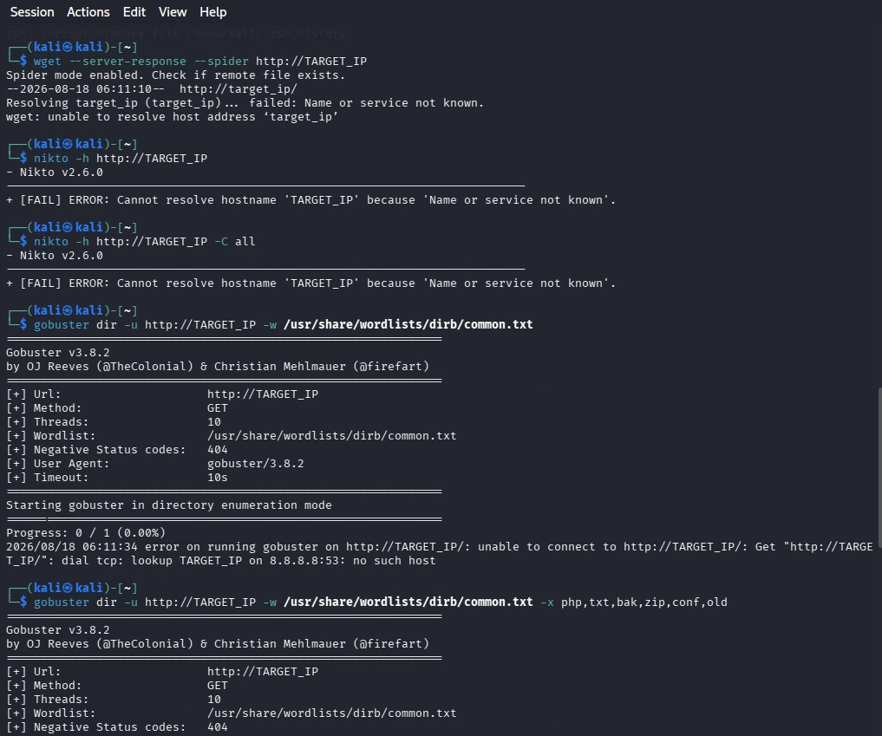
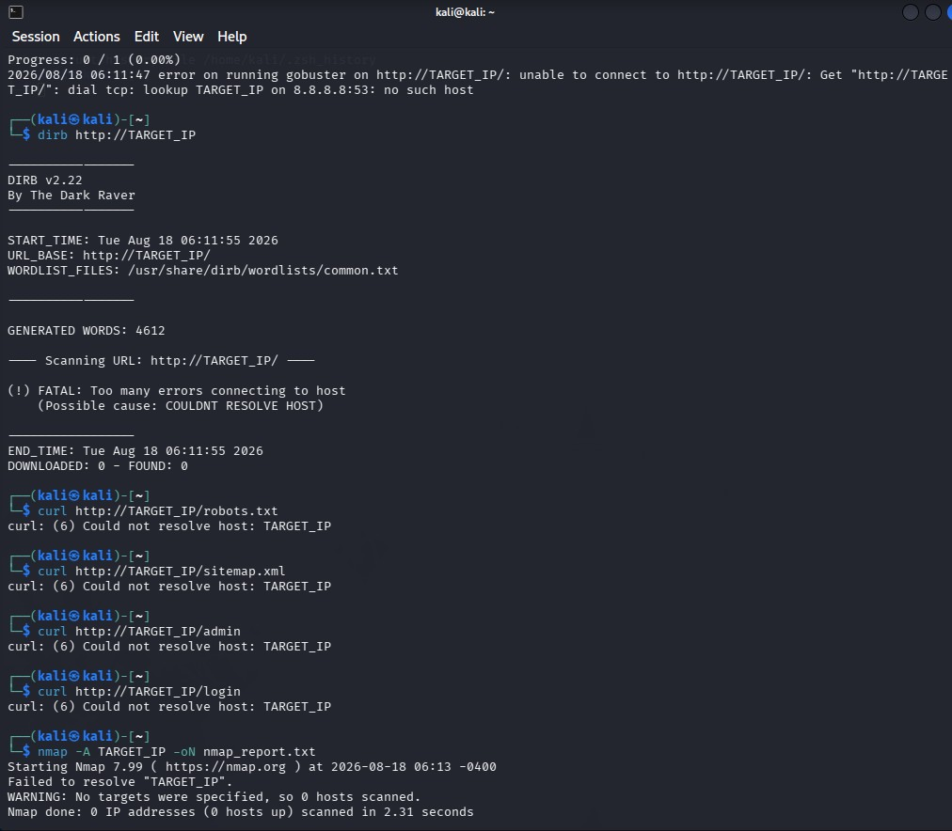

QUESTION 2: Web Application Vulnerability Assessment

Aim
To identify the technology stack and attack surface of an authorized vulnerable web application, examine input fields, parameters, cookies, sessions and HTTP requests, and detect vulnerabilities such as SQL Injection, Cross-Site Scripting (XSS), insecure authentication, session-management weaknesses, directory traversal and security misconfigurations.

Algorithm / Process
- Confirm target URL and test accounts provided by faculty.
- Map technologies and attack surface using appropriate reconnaissance tools.
- Intercept and examine HTTP requests, parameters, cookies and sessions with Burp Suite, OWASP ZAP and browser Developer Tools.
- Test for injection flaws such as SQL Injection and XSS using controlled payloads in the authorized laboratory.
- Evaluate authentication and session management, including cookie flags and session behavior.
- Check for directory traversal and security misconfigurations.
- Validate findings manually and assign severity based on likelihood and impact.
- Document evidence and provide remediation and secure-coding recommendations.

Vulnerability Findings
Vulnerability | Location / Evidence | Severity | Impact
SQL Injection | Login/search parameter; errorbased or boolean response difference in lab | Critical | Data extraction, authentication  bypass, potential  RCE
Reflected XSS | Search/comment fields; payload reflected without | High | Session hijacking, credential theft
 | encoding
Insecure  Authentication | Weak password policy, no account lockout, credentials in  URL | High | Account takeover
Session  Management  Weakness | Session cookie missing  HttpOnly/Secure flags; predictable IDs | Medium–High | Session fixation/hijacking
Directory Traversal | File download parameter allows ../ sequences (lab confirmed) | High | Arbitrary file read
Security  Misconfiguration | Verbose errors, default credentials on admin panel | Medium | Information leak and easier further attacks

Risk Analysis & Secure Coding Practices
- Use parameterized queries / prepared statements for all database interactions.
- Apply context-aware output encoding and Content-Security-Policy.
- Enforce strong password policy, multi-factor authentication where possible, and account lockout.
- Set Secure, HttpOnly and SameSite cookie attributes; regenerate session IDs on login and implement proper logout.
- Validate and sanitize file-path inputs; use allow-lists and isolation mechanisms where feasible.
- Disable detailed error messages in production; remove default credentials and unused features.
- Perform regular code reviews and integrate SAST/DAST into the development lifecycle.

Conclusion
The authorized web application was systematically assessed using automated tools and manual techniques. Multiple high-severity issues including injection flaws and session weaknesses were identified and validated. Implementing the recommended secure-coding and configuration controls will substantially reduce the application’s risk exposure.

Evidence Screenshots
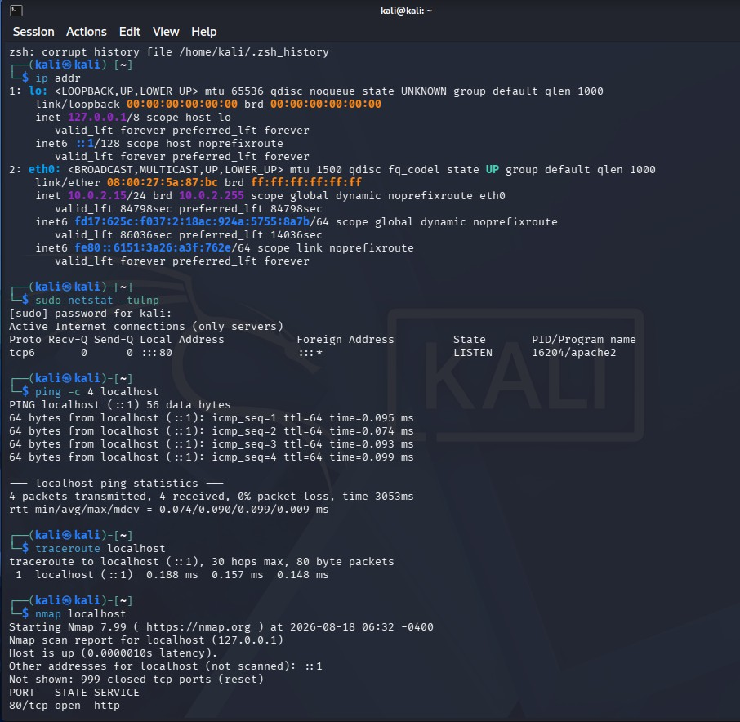
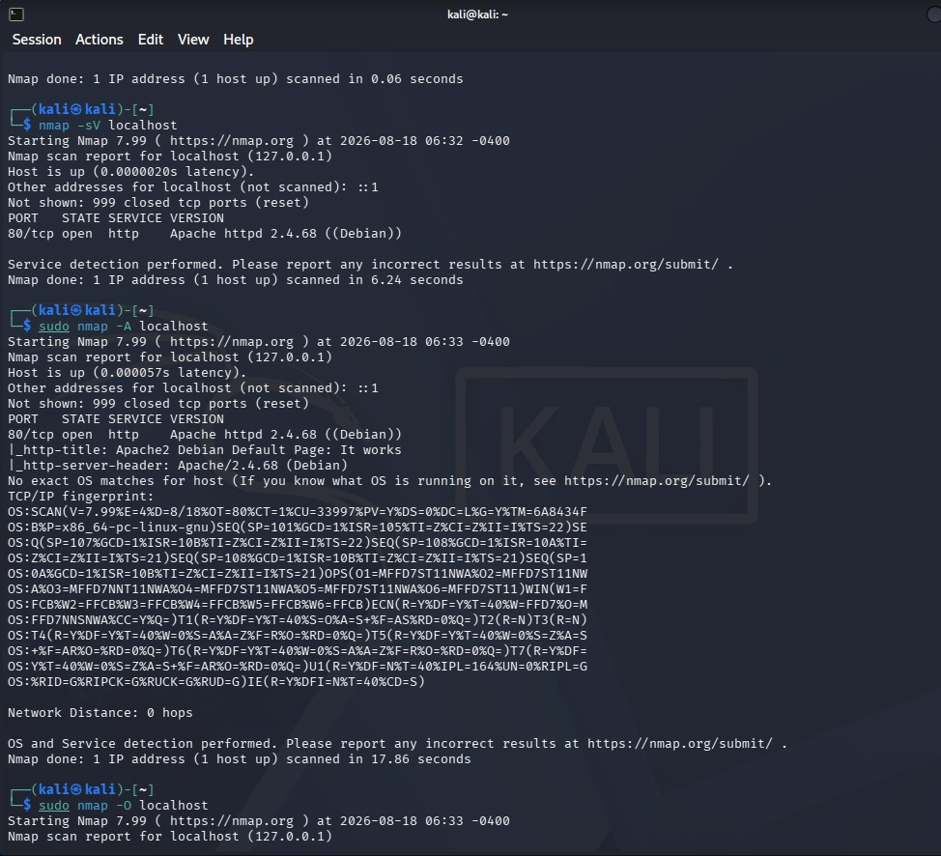
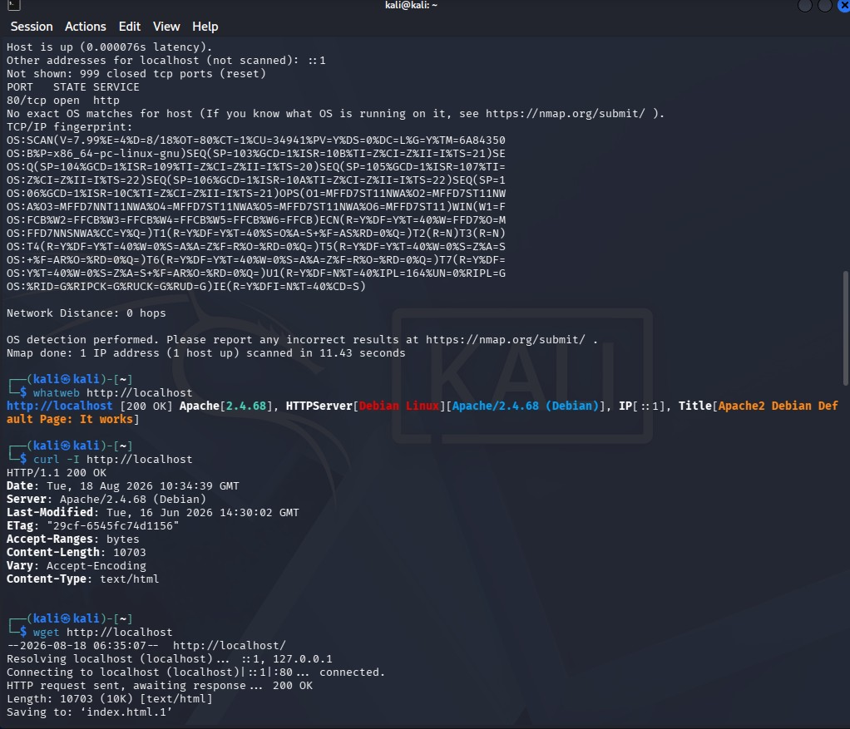
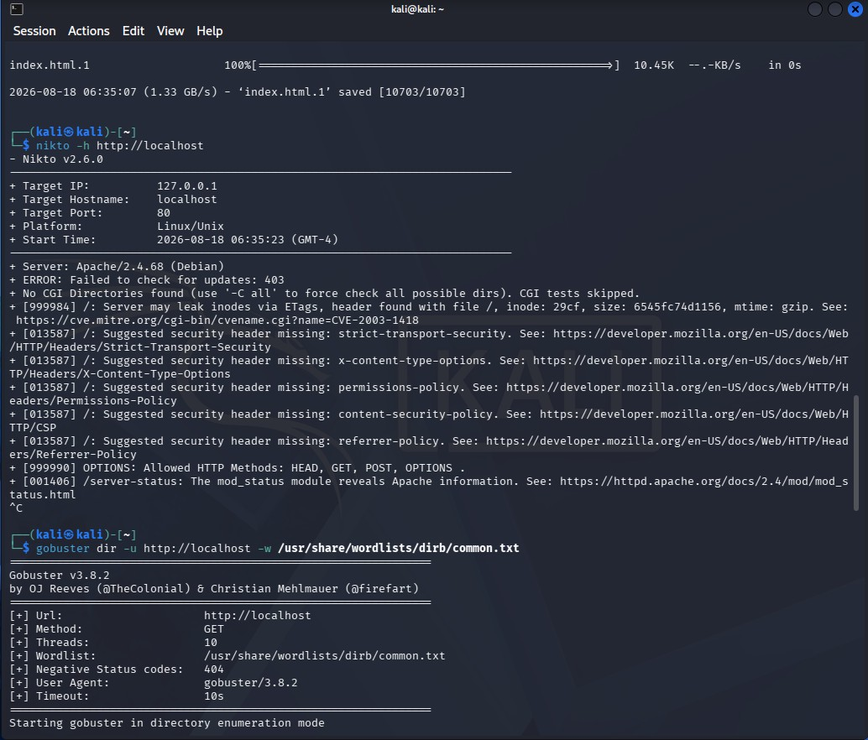
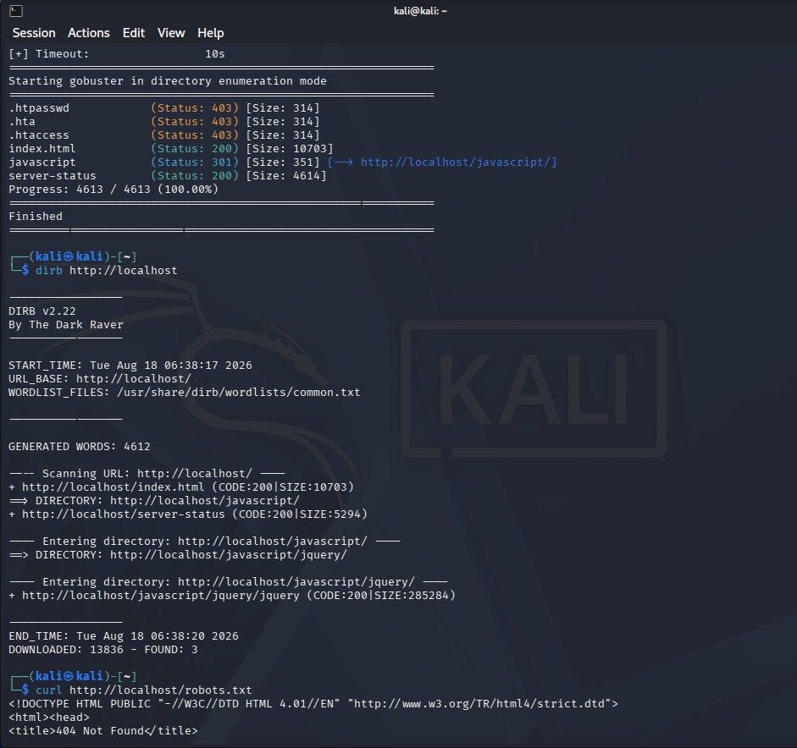

QUESTION 3: Security Header and HTTPS Configuration Assessment

Aim
To examine the HTTPS/TLS configuration and HTTP security headers of an authorized web application using Curl and Nmap SSL scripts; identify missing or misconfigured headers, weak protocols/ciphers and certificate issues; classify severity and recommend hardening measures.

Algorithm / Process
- Confirm the target URL supports HTTPS.
- Fetch and inspect response headers with Curl.
- Run Nmap SSL/TLS scripts such as ssl-enum-ciphers and ssl-cert.
- Check for automatic HTTP-to-HTTPS redirection.
- Evaluate presence and correctness of security headers.
- Analyze TLS protocol versions, cipher suites and certificate validity. • Assign severity and recommend concrete hardening steps.

Sample Commands
curl -I http://<authorized-target> curl -I https://<authorized-target>
nmap --script ssl-enum-ciphers -p 443 <authorized-target> nmap --script ssl-cert -p 443 <authorized-target>

Identified Issues
Issue | Observation | Severity | Security Purpose / Impact
Missing HSTS | No StrictTransportSecurity header | Medium | Users can be forced onto  HTTP (MITM)
Missing CSP | No ContentSecurity-Policy header | Medium–High | Increases impact of XSS attacks
Missing X-  Frame-Options | Header absent | Medium | Clickjacking possible
Missing XContent-TypeOptions | Header absent | Low–Medium | MIME-sniffing attacks
Weak TLS / Ciphers | TLS 1.0/1.1 enabled or weak ciphers present | High | Downgrade / cryptographic attacks
Certificate issues | Self-signed or near-expiry certificate in lab | Medium | Trust / MITM  risk for clients
No  HTTP→HTTPS  redirect | HTTP site still serves content | Medium | Clear-text traffic exposure

Remediation Recommendations
- Enable HSTS with a suitable max-age and includeSubDomains after confirming full HTTPS coverage.
- Deploy a strict Content-Security-Policy tailored to the application.
- Add X-Frame-Options: DENY or SAMEORIGIN and X-Content-Type-
Options: nosniff.
- Disable TLS 1.0 and 1.1; prefer TLS 1.2+ with strong cipher suites.
- Use a valid certificate from a trusted CA.
- Force permanent HTTP-to-HTTPS redirection.
- Regularly re-test the configuration after changes.

Conclusion
Header and TLS analysis revealed several missing defensive headers and configuration weaknesses. These issues do not by themselves grant direct access but can amplify the impact of other vulnerabilities, especially XSS and MITM attacks. Implementing the recommended header and TLS hardening measures provides defense-in-depth.

Evidence Screenshots
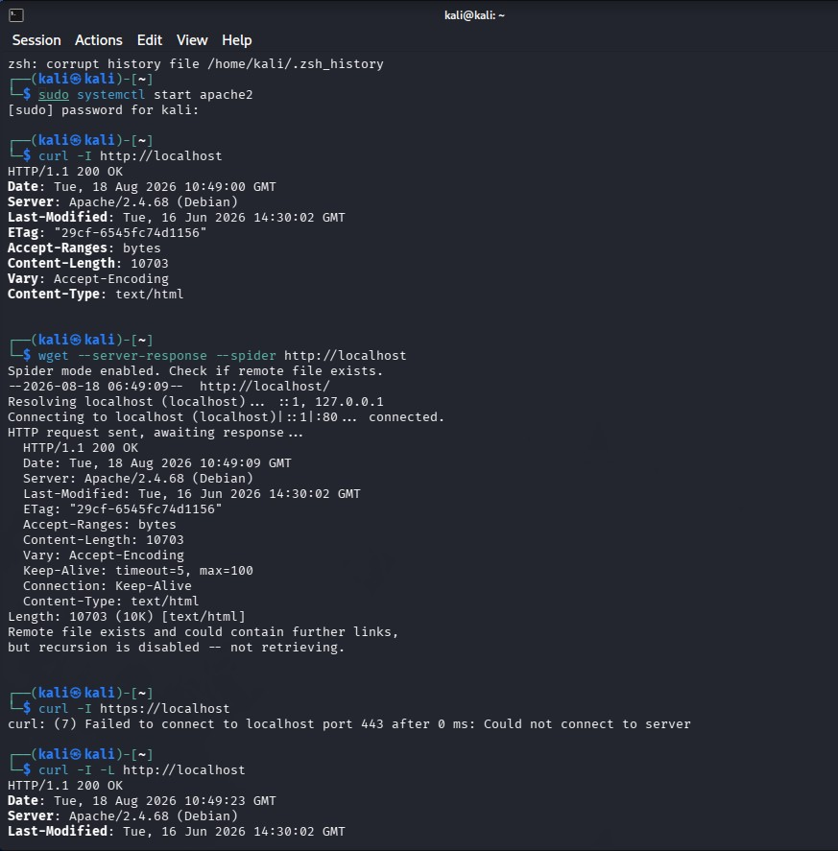
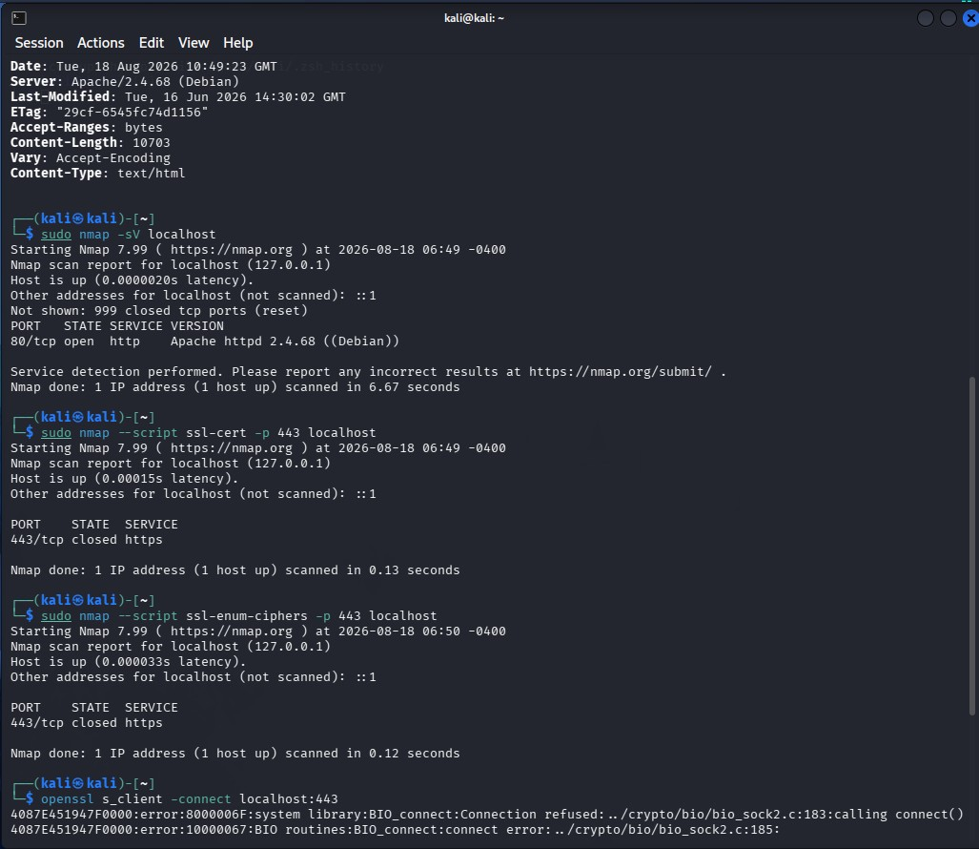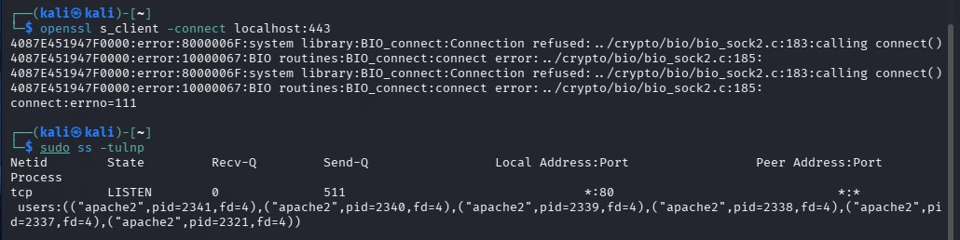

QUESTION 4: Broken Access-Control Assessment

Aim
Using an authorized student portal containing separate student and administrator test accounts, capture and analyze requests with OWASP ZAP, identify object identifiers, and determine whether horizontal or vertical privilege escalation is possible.

Algorithm / Process
- Obtain faculty-provided student and administrator test accounts and test object IDs.
- Configure the browser to proxy through OWASP ZAP.
- Log in as Student A and access own records; capture requests containing object identifiers.
- Using only the provided test identifiers, attempt to access Student B’s records.
- Attempt to access administrator-only resources with the student session.
- Compare server responses for authorized and unauthorized requests.
- Document whether the failure is authentication-related or authorizationrelated.
- Classify severity and recommend server-side fixes.

Authentication vs Authorization
Authentication answers: “Who are you?” It establishes identity through login and session validity.
Authorization answers: “What are you allowed to do?” It determines whether the authenticated identity has permission to access a resource or perform an action.

Testing Results
Test Case | Action | Result | Classification
Horizontal – Student A → Student B | Change object ID in URL/API to another test student's ID | Other student's data returned (200 OK) | Broken Access Control – High
Vertical – Student  → Admin | Request admin dashboard/admin API with student session | Admin page or sensitive data returned | Broken Access  Control – Critical
Unauthenticated access | Request protected resource without session cookie | Redirect to login (401/302) | Authentication correctly enforced

Risk Analysis & Remediation
Severity: High to Critical. A low-privilege account may be able to view or modify other users’ data or perform administrative actions.
- Enforce authorization checks on every request that accesses a sensitive object.
- Never rely on client-side hiding for authorization.
- Use indirect object references or map internal IDs where appropriate.
- Implement role-based or attribute-based access control and verify the current user’s role.
- Log and monitor failed authorization attempts.
- Apply least privilege and deny access by default.

Conclusion
Testing in the authorized laboratory portal confirmed broken access-control vulnerabilities allowing horizontal and vertical privilege escalation. Authentication was present, but authorization checks were missing or insufficient. Server-side role validation and secure object-reference mechanisms are essential to remediate these issues.

Evidence Screenshots
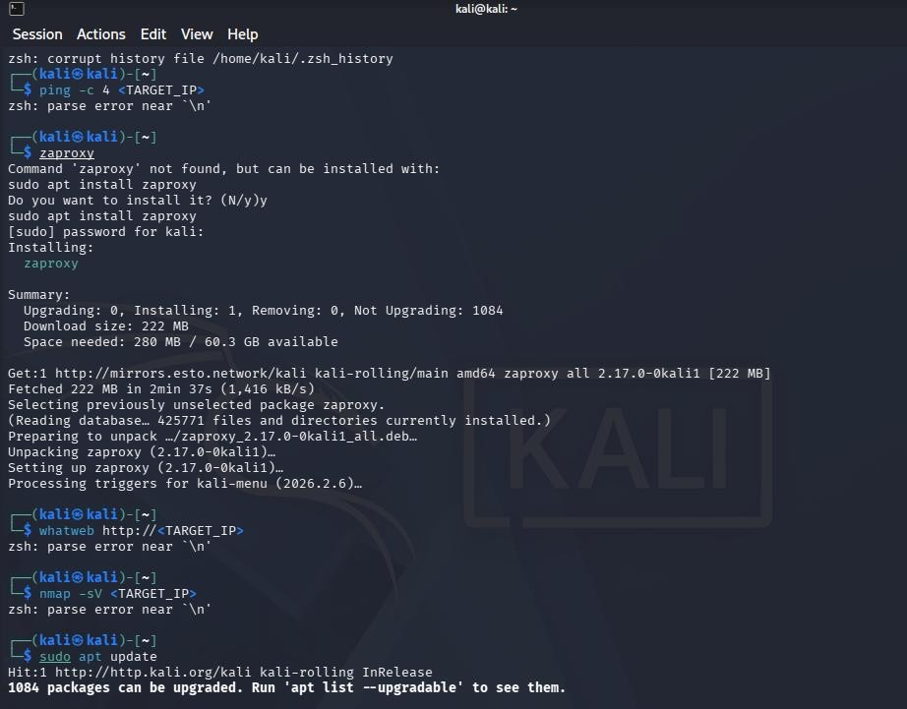

QUESTION 5: Automated Scanning and Manual Validation

Aim
To perform automated vulnerability scanning of an authorized web application using Nikto and Wapiti or OWASP ZAP, compare reported issues, select at least three findings for safe manual validation, determine true positives versus false positives, assign severity, and recommend practical remediation measures.

Algorithm / Process
- Run Nikto against the target to identify server misconfigurations and outdated components.
- Run Wapiti or OWASP ZAP active scan for application-level issues.
- Collect and normalize findings from both tools.
- Categorize findings into Misconfiguration, Information Disclosure, Authentication, and Injection.
- Select at least three findings for manual validation inside the lab.
- Confirm, mark as false positive, or flag for further investigation.
- Assign severity based on likelihood and impact and document remediation.

Tool Outputs Summary
Finding (Tool) | Category | Manual  Validation  Status | Severity
Outdated Apache / PHP (Nikto) | Misconfiguration | Version confirmed via headers & banners – Confirmed | Medium
Missing security headers (Nikto/ZAP) | Misconfiguration | Curl -I verified absence of HSTS,  CSP, etc. –  Confirmed | Medium
Possible SQL  Injection  (ZAP/Wapiti) | Injection | Manual payload produced  differential | Critical
 |  | response/error – Confirmed
Directory listing (Nikto) | Information Disclosure | Browser access showed file list – Confirmed | Medium
Cross-site scripting (ZAP) | Injection | Reflected payload executed in controlled browser – Confirmed | High
Potential session issue (ZAP) | Authentication | Cookie flags examined; further investigation needed | Medium

Manual Validation Evidence
- SQL Injection — Confirmed, Critical: Controlled input in a search parameter produced a database error message and different response lengths for true/false conditions inside the laboratory. Impact: potential full database compromise.
- Missing Security Headers — Confirmed, Medium: Curl and browser Developer Tools confirmed absence of Strict-Transport-Security, ContentSecurity-Policy, X-Frame-Options and X-Content-Type-Options.
- Directory Listing — Confirmed, Medium: Direct browser access to a discovered path returned an index of files, including potentially sensitive backups.

Remediation Measures
- Patch web server and application frameworks to current supported versions.
- Implement parameterized queries and input validation for SQL Injection prevention.
- Deploy comprehensive security headers and enforce HTTPS.
- Disable directory listing and remove unnecessary files and backups from the web root.
- Encode all untrusted output and adopt a strict CSP for XSS mitigation.
- Re-run scans after remediation and maintain continuous monitoring.

Conclusion
Automated scanners such as Nikto and ZAP/Wapiti provided a broad initial view of the attack surface. Manual validation confirmed several true positives, including injection, missing security headers and directory listing, while demonstrating the necessity of human analysis to eliminate false positives and assess real impact.

Evidence Screenshots
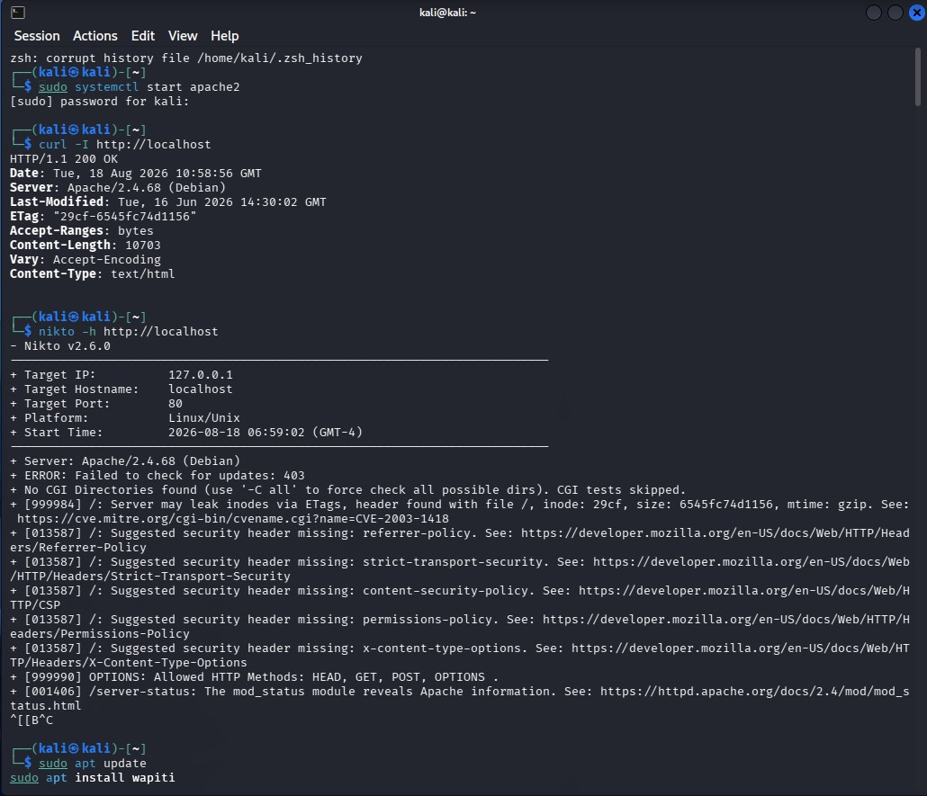
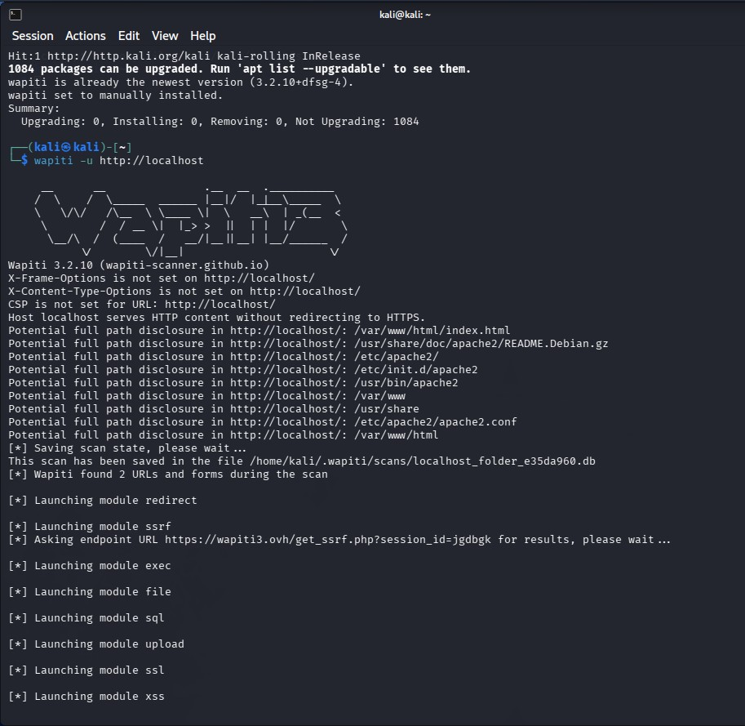
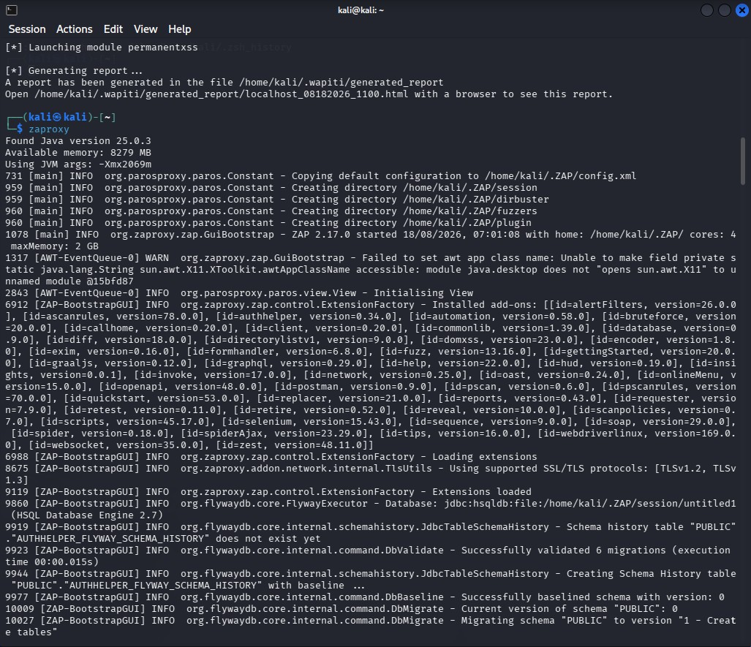
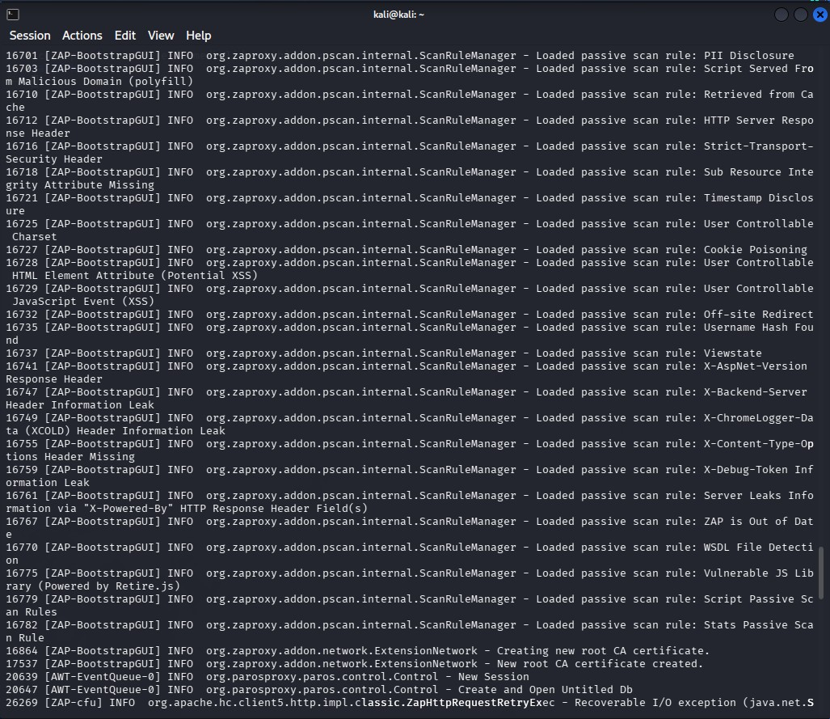
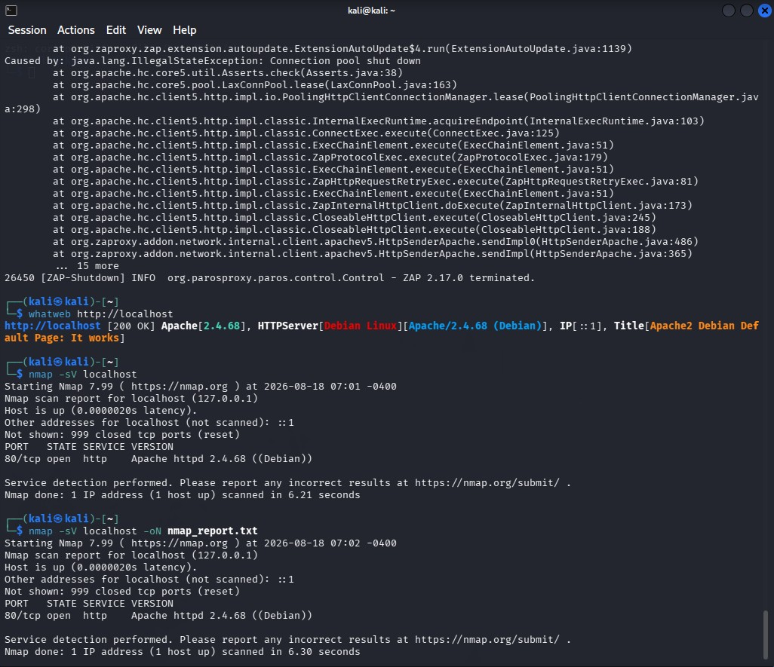

Overall Conclusion
The CO4 Ethical Hacking assessment demonstrates a structured approach to web security testing in an authorized laboratory environment. The report covers reconnaissance, web-server analysis, web-application vulnerability assessment, HTTPS/TLS and security-header analysis, broken access-control testing, and automated scanning with manual validation.
The assessment highlights the importance of validating automated findings manually, classifying vulnerabilities according to likelihood and impact, and applying practical remediation measures. Secure configuration, timely patching, input validation, strong authentication, server-side authorization, secure session management, HTTPS enforcement, and security headers are essential controls for reducing web application risk.
All security testing must remain within the faculty-approved scope and laboratory environment.

References / Tools Used
- Nmap – Network discovery and service/version detection
- WhatWeb – Web technology identification
- Curl/Wget – HTTP response and header analysis
- Nikto – Web-server vulnerability and configuration scanning
- Gobuster/Dirb – Directory and file enumeration
- Burp Suite – HTTP request interception and manual testing
- OWASP ZAP – Web application security testing
- Wapiti – Automated web application scanning
- Browser Developer Tools – Request, cookie and client-side analysis

